- Install nginx and run nginx on port number 81.

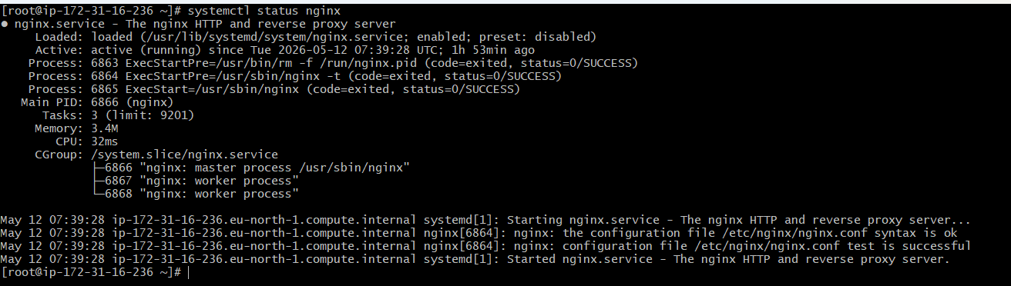


- Deploy a sample index.html file on nginx.

- Install Apache and run Apache on port number 82
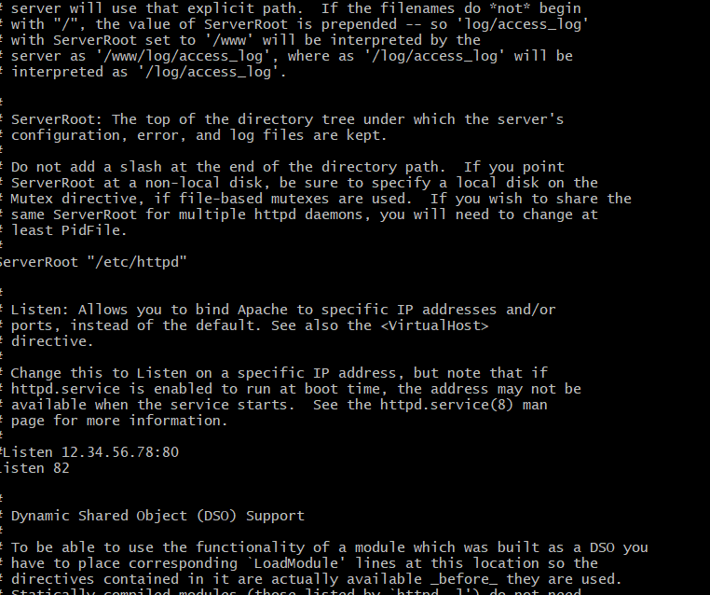

- Deploy a sample index.html file on Apache.

- Install Apache tomcat on port number 8082
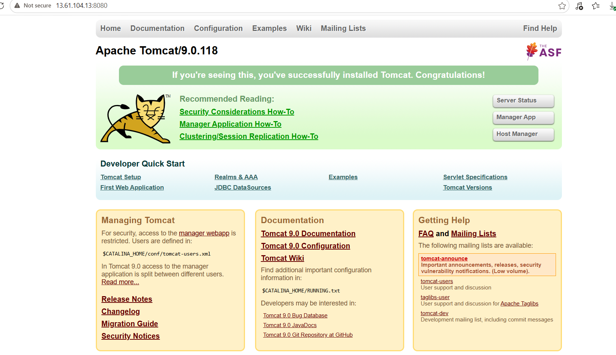

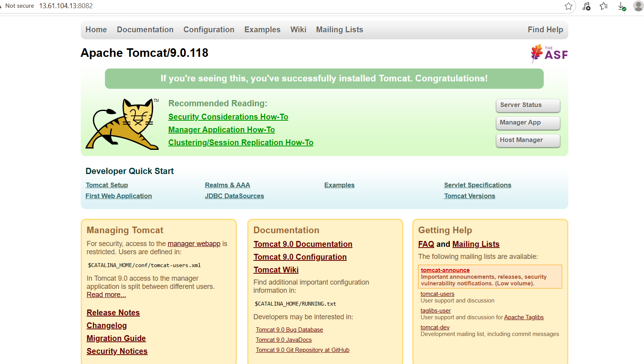

- Deploy a sample app on webapps

- Create a tomcat.service file for tomcat.
ractical: Create and Verify Tomcat Service (systemd)
- 🎯 Aim
- To create a tomcat.service file and run Apache Tomcat using systemctl commands.

- 🧰 Step 1: Create Tomcat service file
- sudo nano /etc/systemd/system/tomcat.service

- 🧾 Step 2: Add the following content
- [Unit]
Description=Apache Tomcat Web Server
After=network.target
[Service]
Type=forking
User=root
Group=root
Environment="JAVA_HOME=/usr/lib/jvm/java-17-amazon-corretto"
Environment="CATALINA_HOME=/opt/apache-tomcat-9.0.118"
Environment="CATALINA_BASE=/opt/apache-tomcat-9.0.118"
ExecStart=/opt/apache-tomcat-9.0.118/bin/startup.sh
ExecStop=/opt/apache-tomcat-9.0.118/bin/shutdown.sh
Restart=always
[Install]
WantedBy=multi-user.target

- 💾 Step 3: Save the file
- Press CTRL + X
- Press Y
- Press Enter

- 🔄 Step 4: Reload systemd manager
- sudo systemctl daemon-reload

- ▶️ Step 5: Start Tomcat service
- sudo systemctl start tomcat

- 📊 Step 6: Check service status
- sudo systemctl status tomcat
- ✔ Output should show:
- Active: active (running)

- 🚀 Step 7: Enable auto-start on boot
- sudo systemctl enable tomcat

- 🌐 Step 8: Verify in browser
- Open:
- http://<server-ip>:8082

- 🧪 Step 9: Check port status
- sudo ss -tulnp | grep 8082

- 🎯 Result
- Tomcat service is successfully created, started, and verified using systemctl.

- 📌 Conclusion
- We successfully created a systemd service file for Apache Tomcat and managed it using Linux service commands.
- 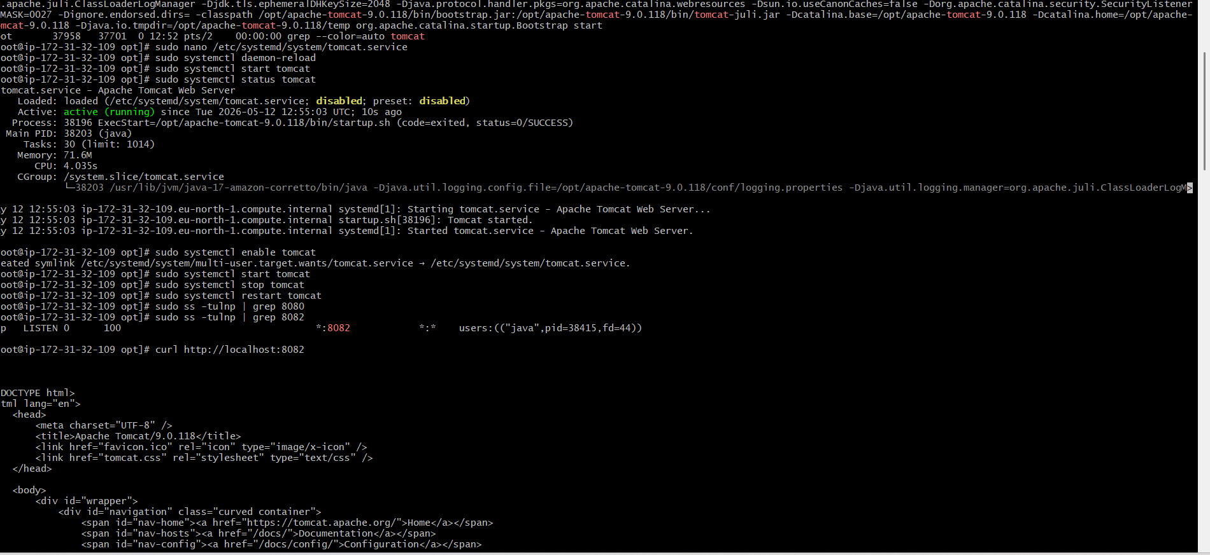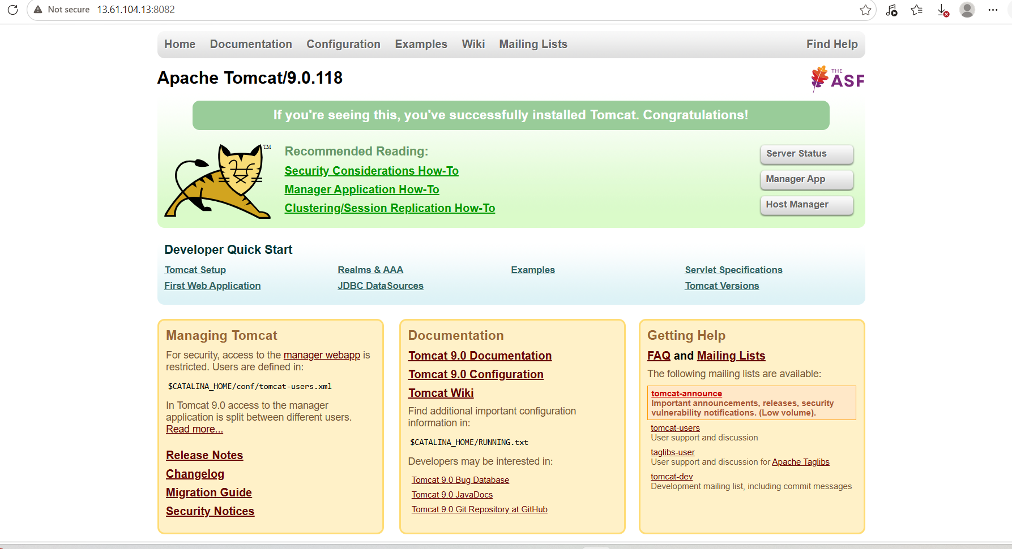
- Configure HA Proxy server
Server :1
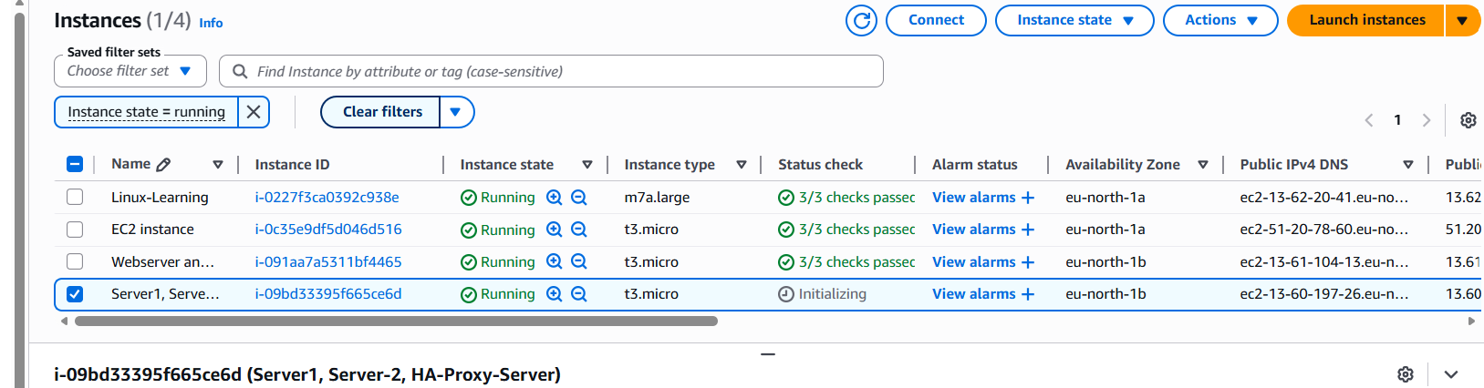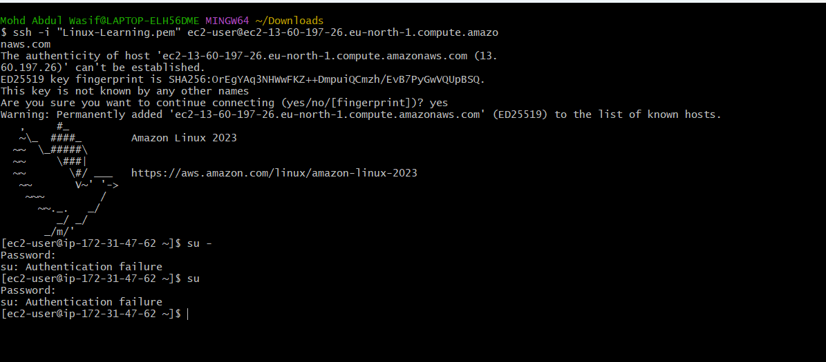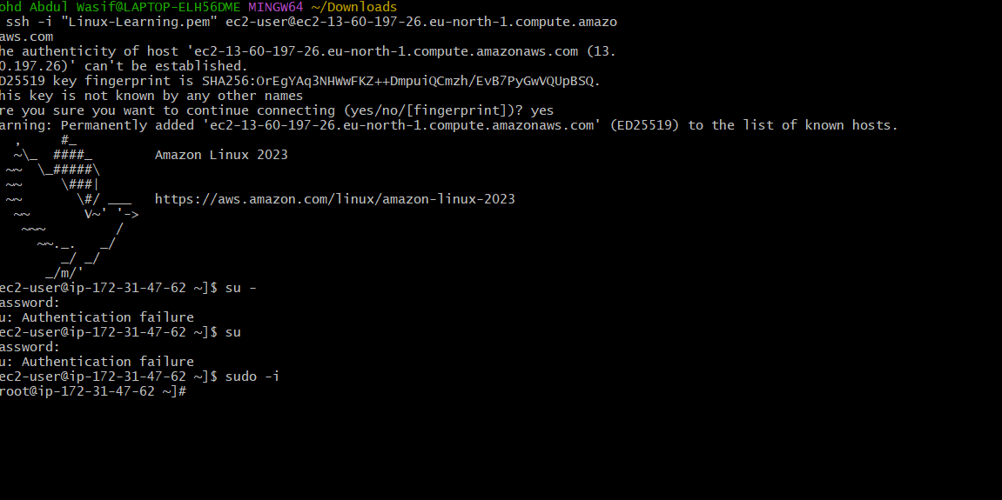
Yum update -y
then install httpd
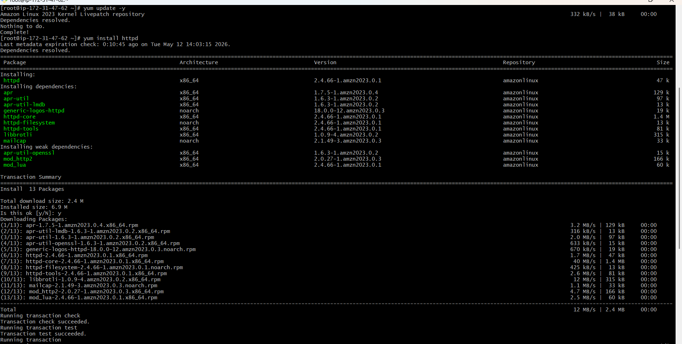
command : vi /etc/hosts
added ip address to etc/hosts
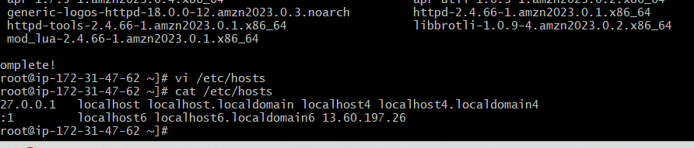
run load balancer
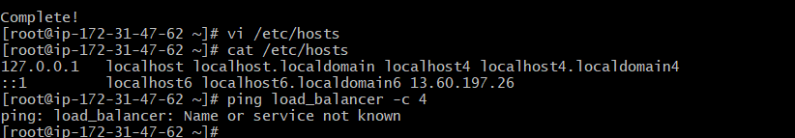
Then start and check status by systemctl command
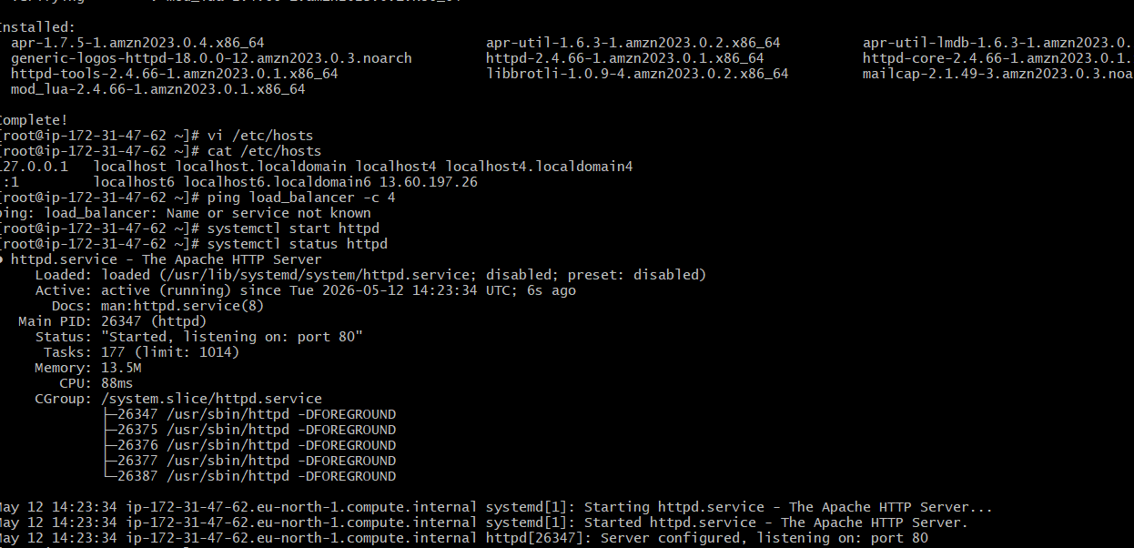

Server 02

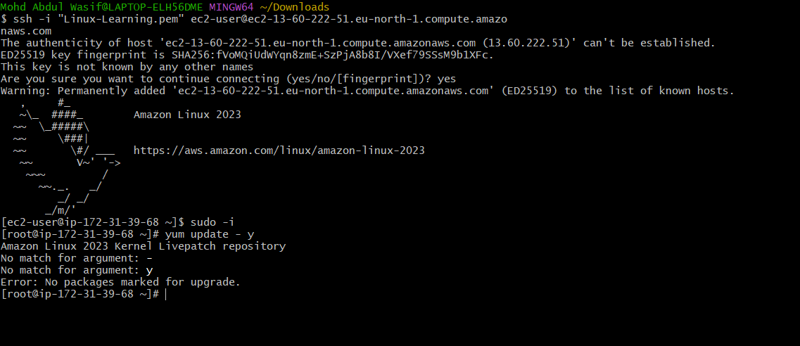
nginx installed
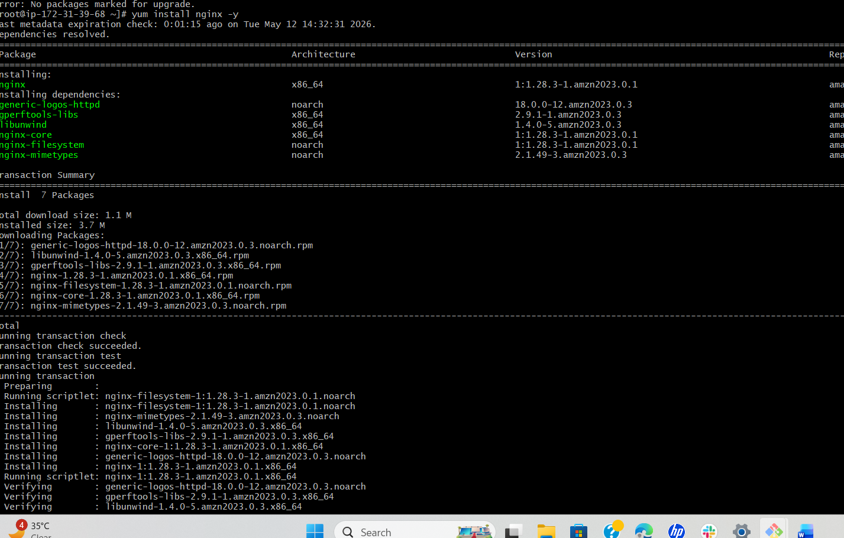
added ip address

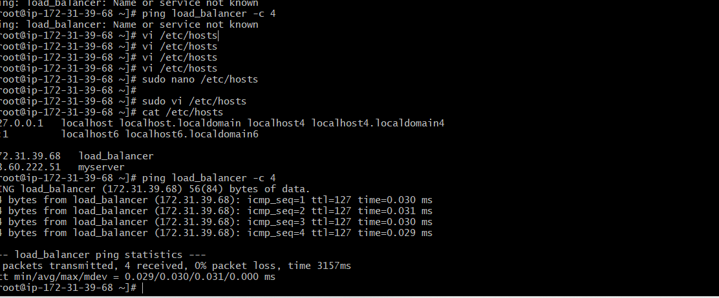
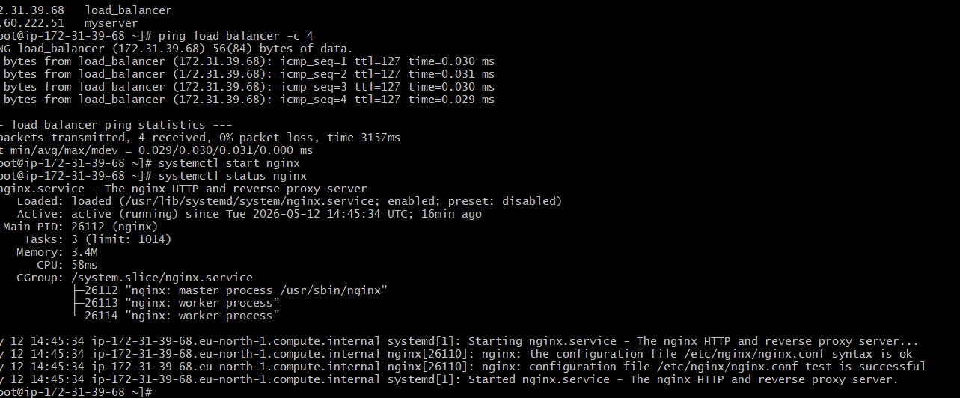

HA-Proxy-Server Steps:
Run following command to Access HA-Proy-Server
• ssh -i your-key.pem ec2-user@Pubipaddress of HA-Proxy-Server instance
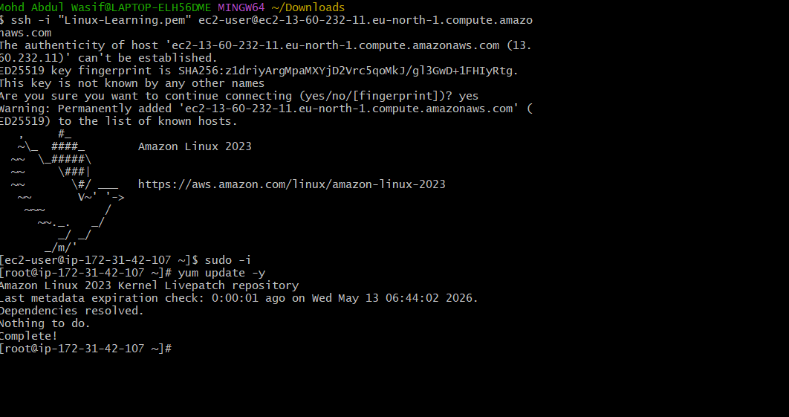
yum install haproxy -y
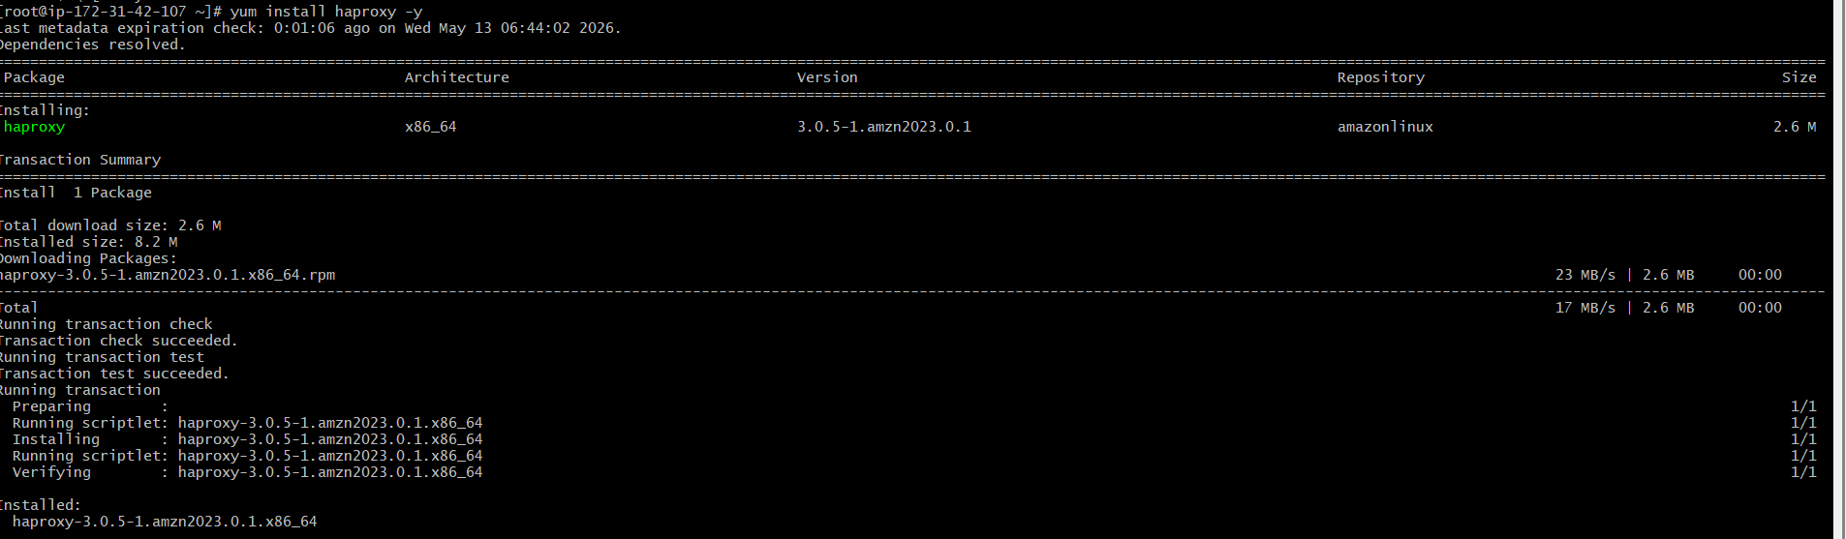
vi /etc/hosts
• Add Server-1, Server-2 Public IP’s
vi /etc/haproxy/haproxy.cfg
• Add Server-1, Server-2 public IP’s
cat /etc/haproxy/haproxy.cfg
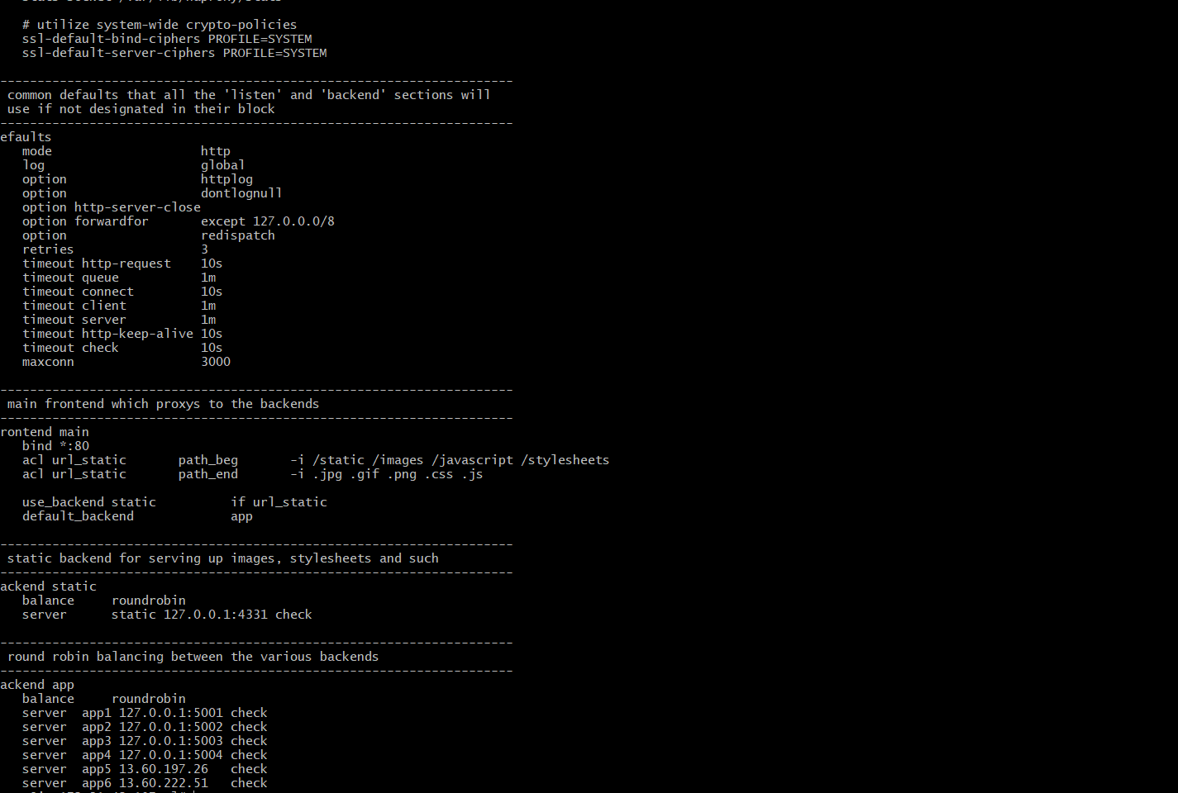
systemctl enable haproxy
• systemctl start haproxy
• systemctl status haproxy
